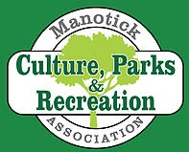
Manotick Culture Parks and Recreation Association (MCPRA)

2026 Membership Form

First Name: __________________________________________________

Last Name: __________________________________________________

Address: __________________________________________________

E-mail: __________________________________________________

Phone (H): ___________________________

Phone (C): ___________________________

Primary Interests (Please check any areas of interest)

_____ Culture _____ Events _____ Parks & Pathways _____ Recreation _____ Board Member

_____Other (Please Specify) ______________________________________

I consent to receiving electronic correspondence from MCPRA through my email address. ____ (Initial)

Membership Fee: _____ $20 for Family _____ $10 for an Individual

Send an e-transfer to: mcpra.treasurer@gmail.com OR

Make your cheque payable to the MCPRA and mail to:
Jon Mack, Treasurer
5843 Rideau Valley Dr N
Manotick ON K4M 1B3

This membership form must accompany your membership fee.

Manotick Culture, Parks, & Recreation Association (MCPRA) is a non-profit, incorporated, volunteer organization that leads & supports environmentally responsible culture, parks & recreation community projects & services in Manotick.

